Game Theory

- 2-Player Game:
- Finite Game:

- Deterministic Game: outcome is fully determined by the current state of the game and the actions or moves taken by the players, without any element of randomness.

- Sequential Game: players take turns making moves, one player makes a decision or move first, followed by the other player, who observe the previous move of the opponent before deciding their next move.

- Perfect information Game: all players are fully aware of all events, actions, and choices that have taken place up to the current point in the game.
Every player knows the state of the game, including the decisions made by others.
There is no hidden or private information.
Like chessboard (not like decks).
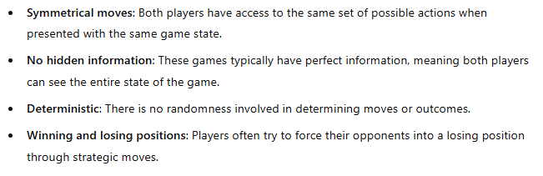
- Impartial Game: a type of combinatorial game where the available moves depend only on the current position or state of the game, and not on which player is making the move (same for both players).

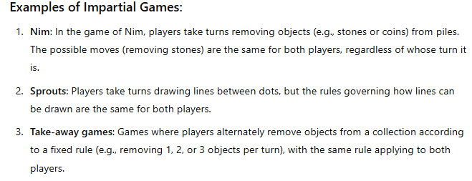

- Partisan Game: a type of combinatorial game where the available moves depend on which player is taking their turn. In these games, each player has their own set of pieces, moves, or actions that are distinct from the other player's.
Impartial Game

- Single Game:
You can determine Winning/Losing state and observe a pattern or solve it using dp. (You have only one state)
(the players play with only one thing)

- Composite Game:
Multiple single games at same time
(multiple states at same time) --> Nim Game

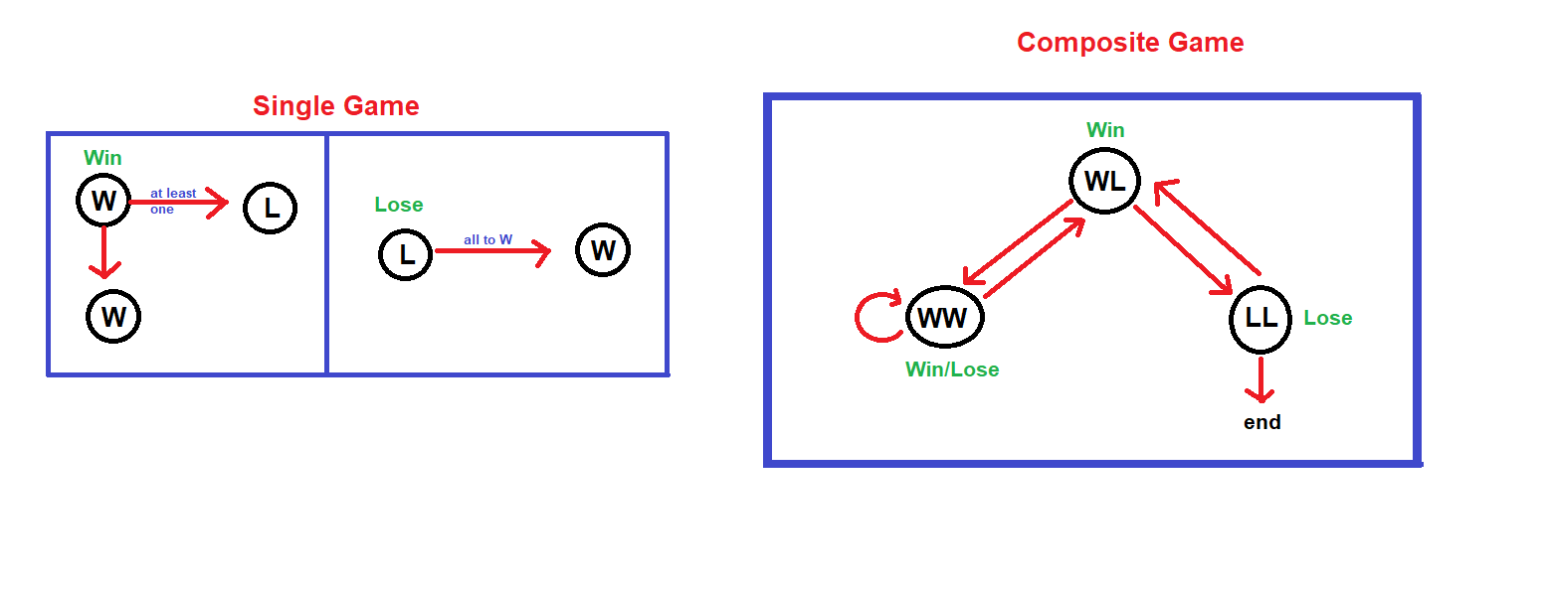

- Nim Game:
Composite perfect-information impartial two-player game.

- a ^ b ^ c = d
i want to minimize only one number to make
(a ^ d) ^ b ^ c = 0, where a ^ d < a
find the number that the xor with d will make it decrease, this number must have the msb of d turned on like d.

- when the xor sum of some elements is non-zero, then I decrease one element from them to make the xor sum becomes zero! (I always can!)

When the xor sum is zero, then minimizing any element with any amount will make the xor sum becomes greater than zero!

- So, when the xor sum of all elements is non-zero, then I’m in a win position, else lose position.
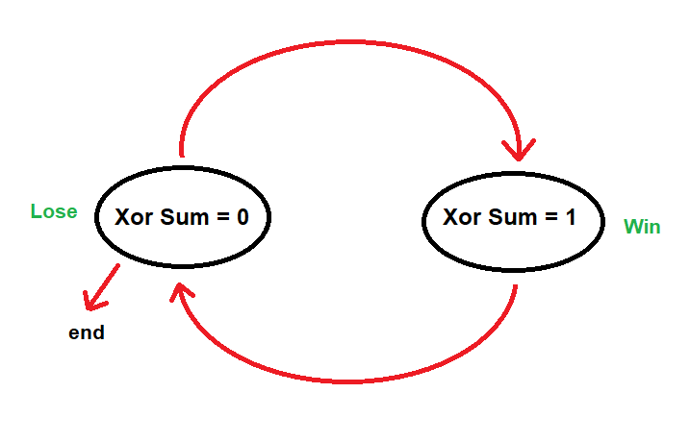

- Nim Game: Many plats each have some balls, u can take out any number of balls from any plate, and the last one who can’t find balls to select loses.
(Xor sum > 0) --> first player wins, else the second player

- Any Impartial Composite game can be converted to Nim Game. (Sprague-Grundy Theorem)
f(a) ^ f(b) ^ f(c) > 0 --> first player wins!
where f(x) returns the Grundy number

- Grundy numbers are the new number of balls in each plate when converted the given problems to Nim Game.

- Steps:
Simulate first few numbers to get the pattern f(x) = ??
f(0) = 0
f(1) = mex({f(states) the 1 can get to})
f(2) = mex({f(states) the 2 can get to})
f(3) = mex({f(states) the 3 can get to})
… and so on --> Build DAG
then get f(x) = ____
Finally, get xor sum of the Grundy numbers!
Search for a pattern if the dp time complexity is bad!
- Any game which can be represented as a DAG can also be formulated in terms of Grundy numbers, and thus Nim!
- Misère Nim:
Modified version of Nim Game, but the one who take the last stone will lose!
The winner will be the same as Nim Game, because u just in ur last move, u can leave only one stone for the opponent!
But there is a small edge case that where all piles contain only 1 stone! (n even --> u win, else the opponent)

- Poker Nim:
On your turn, you can either:
Remove one or more stones from a single pile (like in normal Nim).
Add stones to a single pile (at most k times for each pile).
The winner will be the same as Nim Game.
Because if u start at a win position, u’ll undo all moves of ur opponent.
"Nim where you can add stones" is just the same as normal Nim.

- xor sum = nim sum

- Let G(u) be the Grundy number of a pile with u stones. The Grundy number of a terminal state is 0; otherwise, G(u) is recursively defined as the mex of the Grundy numbers of all the states it points to.

- The important Sprague-Grundy theorem states that these games are equivalent to playing Nim, but instead of getting the Nim-sum by taking the XOR of the piles, we take the XOR of their Grundy numbers.

- Intuition behind mex
In the normal nim game, if a pile has x stones, then it can get to x different states [0, x – 1].
So, it’s Grundy value = it’s value, because mex(0, 1, 2, .., x - 1) = x

The mex function is a promise. The promise is that: if f(p)=g, then it means every integer from 0 to g−1 is "accounted for" in the list of valid moves from p.

Nim product
- ab = mex({a′b ⊕ ab′ ⊕ a′b′ : a′ < a, b′ < b}).

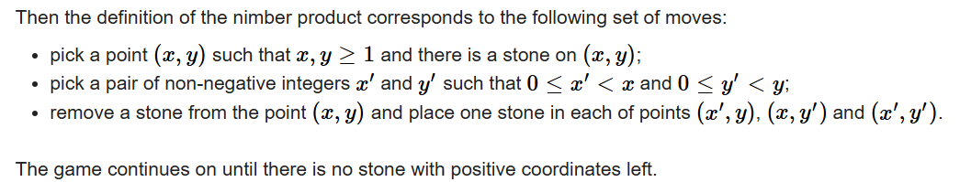
- Problem1: diminishing rectangles game

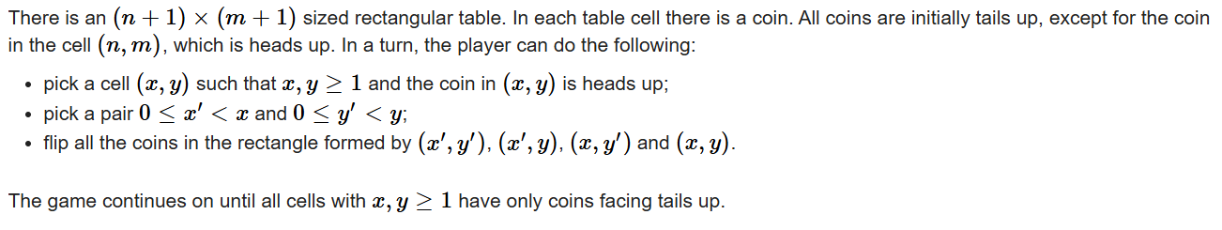
- Problem2: The coin turning game

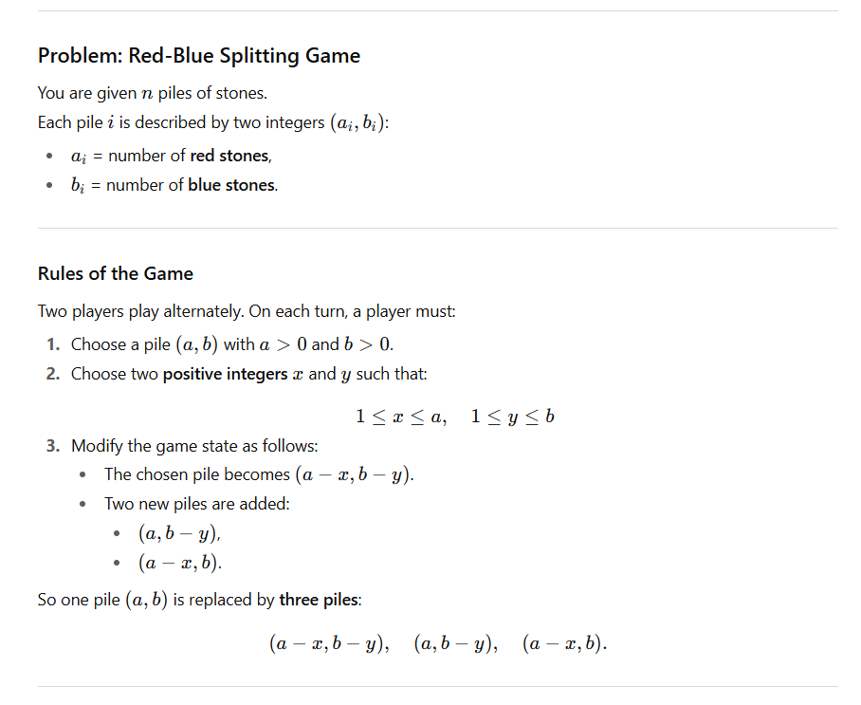
- Problem3:

